The Salvation Army Midland Division

WELCOME…
…to the 2025 Salvation Army Camp Mihaska summer camping season for the Midland Division! Your summer will be filled with opportunities to create exciting memories as we experience God’s creation together in new ways.

Time spent at Camp Mihaska has proven to make a lasting impression and productive on-going change for countless kids and adults. We focus on evangelism and discipleship in all that we plan. Through intentional programming and more importantly showing God’s love and acceptance to each camper, we strive to lead many into a personal relationship with Jesus Christ or deepen their walk with Him.

It is our prayer that every program and activity will reflect the love of God to those He has entrusted to us during these weeks.

DIVISIONAL LEADERSHIP
Divisional Commanders: Majors Robert and Lisa Mueller
Divisional Youth Secretary: Captain Matt DeGonia
Divisional Candidates Secretary: Captain Gini DeGonia

CAMP MIHASKA

Phone: 573-732-5239
Address: 1466 Highway N Bourbon, MO 65441
Camp Director: Terry Mahurin
Guest Relations Director: Joanie Mahurin

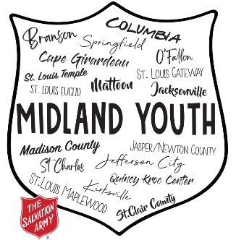
NO VEHICLES WILL BE PERMITTED BEYOND THE MAIN PARKING LOT
PURPOSE OF SALVATION ARMY CAMPING

The purpose of Salvation Army camping is to serve the needs of campers: physical, social, and spiritual. For physical needs, our aim is to help campers develop good healthy habits in cleanliness, proper rest, balanced diet, exercise, and care of the body. To meet social needs, the camp provides an opportunity for each camper to contribute to and receive from a group living experience. The experience aims to help campers make their own right decisions, stimulate creativity and foster independence.

The fact that The Salvation Army is a Christian organization makes it possible for its camping program to integrate concern for the spiritual dimensions of life. We believe in God, His Word, and what it teaches, and a pattern of living exemplified by Jesus Christ.

These purposes are achieved through carefully selected staff, well-planned programs and the highest standards of health and safety.

GOALS OF SALVATION ARMY CAMPING

- To promote an awareness of God, His love, and the grace of Jesus Christ.
- To aid toward spiritual growth and knowledge of basic human values.
- To give children, youth, and adults a fun-filled, healthy, safe, educational, and inspirational experience in the outdoors.
- To help develop an understanding, appreciation, and sense of stewardship for the outdoors, the natural environment, and all living creatures.
- To help individuals grow in understanding themselves and each other. Especially for children to experience relationships with staff as caring adults and to offer opportunity for individuals of varied cultures to develop compassion and love for one another.
- To provide a loving and supportive environment where families can learn to cope with and solve their problems.
- To facilitate creative self-expression through thought, worship, song, work, play, physical activity, and the development of new skills.
- To allow everyone to participate in planning programs and in establishing limits and responsibility for the safety and welfare of all.
To assist in developing an appreciation of the wonder and joy of the miracles of everyday livin

